create database BooksDB;

use BooksDB;

create table Books

(book_id int, book_title varchar(20), author_id int,author_name varchar(20), genre varchar(20), publication_year int, price int, primary key(book_id));

desc Books;

insert into Books values('001','Clean Code','101','Robert C.Martin','classic coding',2000,200);

insert into Books values('002','Mythicla Man-month','102','frederick','software',2003,300);

insert into Books values('003','Pragmatic Program','103','Hector Garcia','development',2022,150);

insert into Books values('004','Programming Pearls','104','Collen Hoover','Programming',2020,400);

insert into Books values('005','Code','105','Charles perzpld','Hardware',2010,250);

select book_id, book_title from Books ;

select*from Books where book_title='Mythicla Man-month';

update Books set price=350 where book_title='Pragmatic Program';

delete from Books where book_title='Code';

select AVG(price)from Books;

select * from Books;

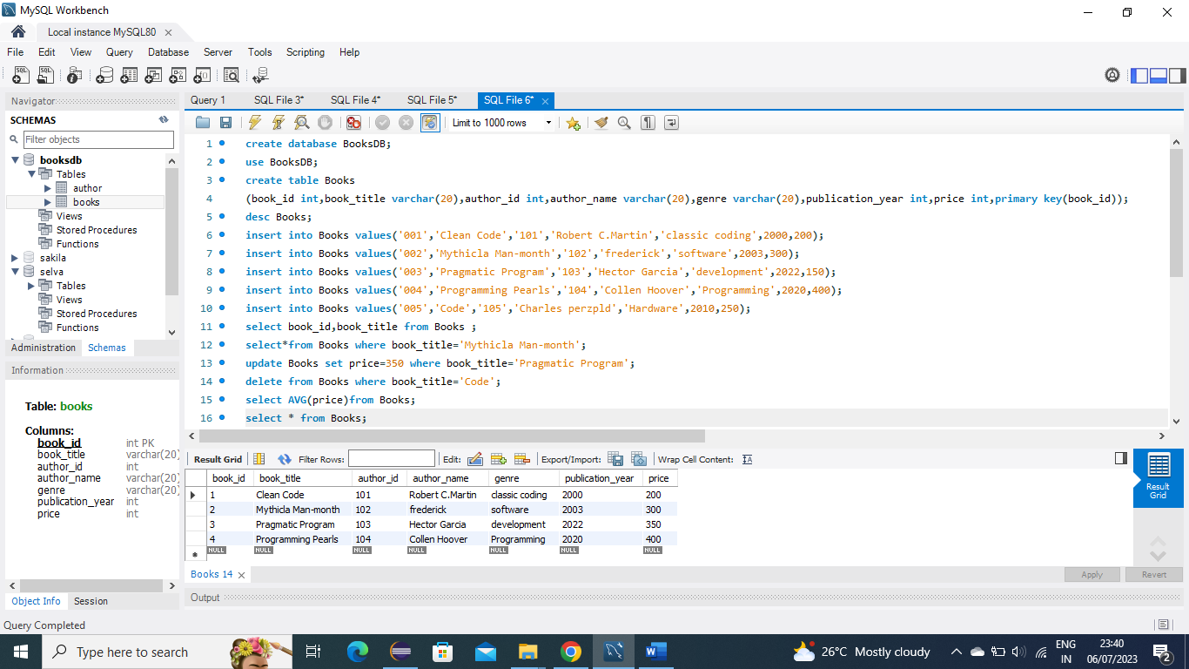

create table Author

(author_id int,author_name varchar(20),author_age int,foreign key(author_id) references Books(author_id);

insert into Author values(101,'Robert C.Martin',45);

insert into Author values(102,'frederick',35);

insert into Author values(103,'Hector Garcia',40);

insert into Author values(104,'Collen Hoover',50);

select * from Author;

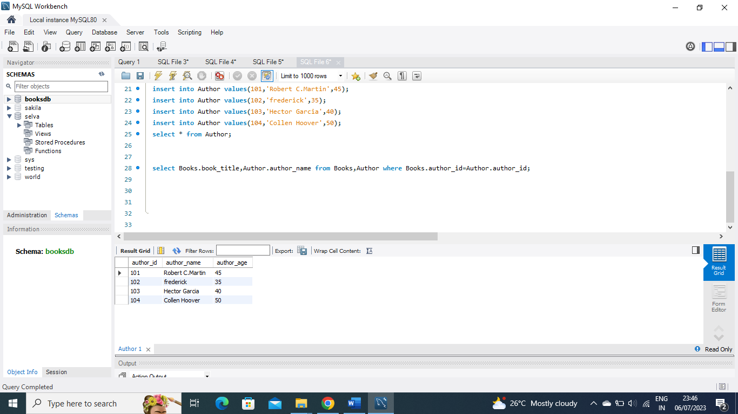

select Books.book_title,Author.author_name from Books,Author where Books.author_id=Author.author_id;

